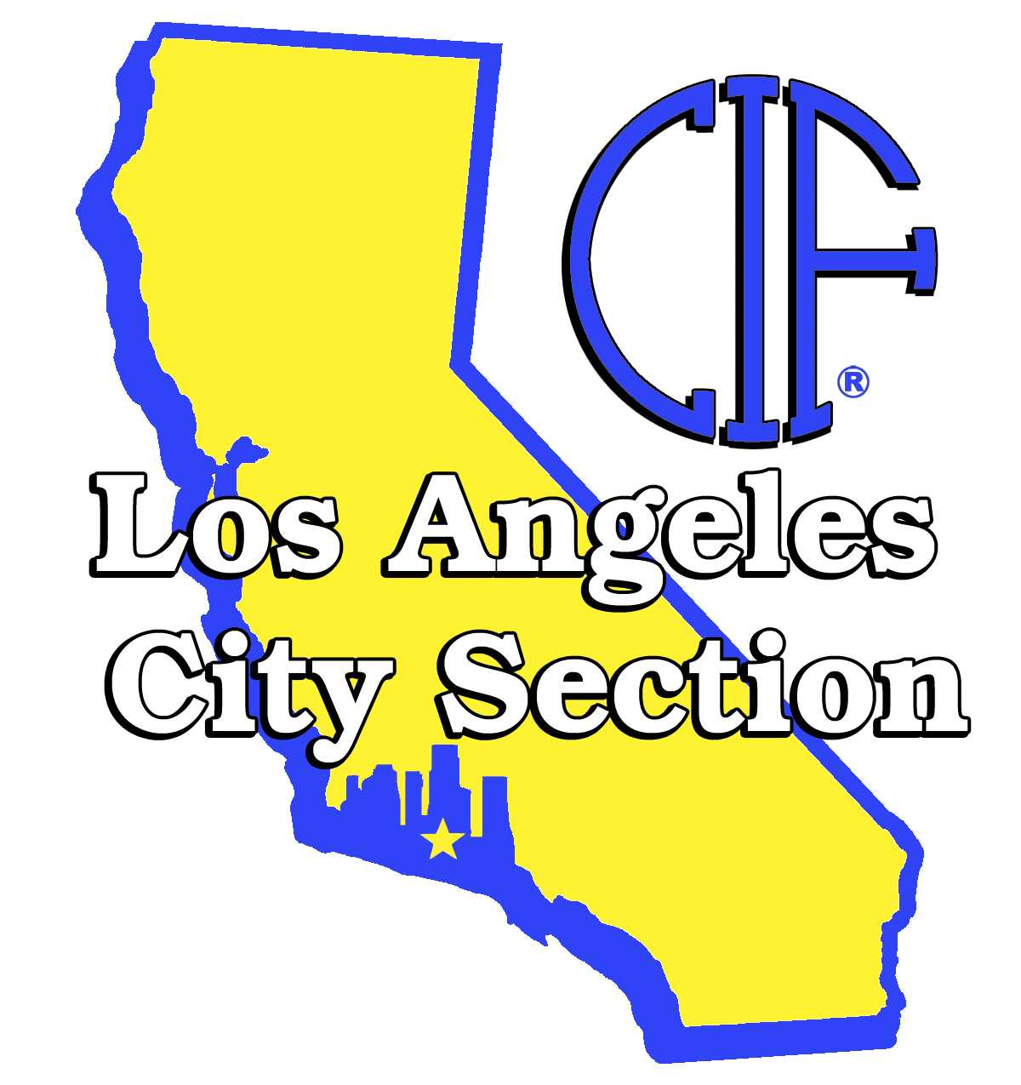
CIF LOS ANGLES CITY SECTION

Telephone (213) 241-5835 Fax (213) 241-5846

SPRING 2012

SCHEDULING

INFORMATION

- Athletic Scheduling Timeline and Due Dates

- Spring Leagues 2012

- Spring Open Dates

- Non League Composite

- Fall 2012 Athletic Scheduling Forms (Due January 11, 2012)

- Final Draft Spring Non League Game Worksheet (Fax hard copy and input games into Schedule Star no later than November 23rd)

